1. **SELECT**: Retrieve all columns from the Doctor table.

1. **ORDER BY**: List patients in the Patient table in ascending order of their ages

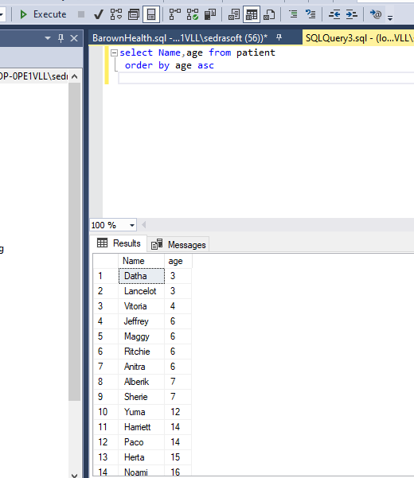

1. **OFFSET FETCH**: Retrieve the first 10 patients from the Patient table, starting from the 5th record.

1. **SELECT TOP**: Retrieve the top 5 doctors from the Doctor table.

1. **SELECT DISTINCT**: Get a list of unique address from the Patient table.

1. **WHERE**: Retrieve patients from the Patient table who are aged 25.

1. **NULL**: Retrieve patients from the Patient table whose email is not provided.

1. **AND**: Retrieve doctors from the Doctor table who have experience greater than 5 years and specialize in 'Cardiology'.

1. **IN**: Retrieve doctors from the Doctor table whose speciality is either 'Dermatology' or 'Oncology'.

1. **BETWEEN**: Retrieve patients from the Patient table whose ages are between 18 and 30.

1. **LIKE**: Retrieve doctors from the Doctor table whose names start with 'Dr.'.

1. **Column & Table Aliases**: Select the name and email of doctors, aliasing them as 'DoctorName' and 'DoctorEmail'.

**انا مسمياه كدا اصلا فغيرته فى الكويرى**

1. **Joins**: Retrieve all prescriptions with corresponding patient names.

1. **GROUP BY:** Retrieve the count of patients grouped by their cities.

**الملف مش موضح ان العنوان متقسم لمدينة وشارع وهكذا !!**

**فهعمل الكويرى بالعنوان**

1. **HAVING:** Retrieve cities with more than 3 patients.

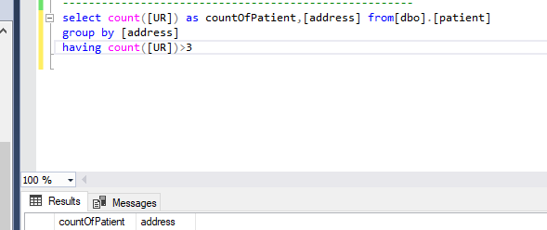

1. **GROUPING SETS:** Retrieve counts of patients grouped by cities and ages.

1. **CUBE:** Retrieve counts of patients considering all possible combinations of city and age.

1. **ROLLUP:** Retrieve counts of patients rolled up by city.

1. **EXISTS**: Retrieve patients who have at least one prescription.

1. **UNION:** Retrieve a combined list of doctors and patients.

1. **Common Table Expression (CTE):** Retrieve patients along with their doctors using a CTE.

1. **INSERT:** Insert a new doctor into the Doctor table.

1. **INSERT Multiple Rows:** Insert multiple patients into the Patient table.

1. **UPDATE:** Update the phone number of a doctor.

1. **UPDATE JOIN:** Update the city of patients who have a prescription from a specific doctor.

**-**--هنا حضرتك مقولتش ان نفس الدكتور اللى متابع المريض يكون هو اللى كتب العلاج فبالتالى معنى الكويرى ان العلاج يكون من دكتور ده الكونديشن

1. **DELETE:** Delete a patient from the Patient table.

1. **Transaction:** Insert a new doctor and a patient, ensuring both operations succeed or fail together.

1. **View:** Create a view that combines patient and doctor information for easy access.

1. **Index:** Create an index on the 'phone' column of the Patient table to improve search performance.

1. **Backup:** Perform a backup of the entire database to ensure data safety.

TITLE: Microsoft SQL Server Management Studio

------------------------------

The backup of database 'BarwonHealth' completed successfully.

------------------------------

BUTTONS:

OK

